Assignment 3

Histogram stretching involves modifying the brightness (intensity) values of pixels in the image according to some mapping function that specifies an output pixel brightness value for each input pixel brightness value.

## Stretching

Stretching is defined by user provided intensity range parameters (a,b). Stretch the intensities in the range between a and b on the input image to the range of c and d as output.

$$I^{'}\left(i,j\right)=\left\{\begin{matrix}0 & if 0 ≤I\left(i,j\right)≤a \\ \left(I\left(i,j\right)-c\right)×\frac{b-a}{d-c}+a & if a<I\left(i,j\right)<b \\ 255 & if b≤I\left(i,j\right)≤255\end{matrix}\right.$$

The stretching applies the user defined ROI.

**Parameters**

|  |  |  |
| --- | --- | --- |
| src: | Address of source image | |
| tgt: | Modified image is saved in this address | |
| Input Vector: | roi_number | Number of defined ROI |
| ROI | Coordinate of target pixels |
| range | Stretching range from a to b |

### **Example**

SampleImages\Gray\baboon.pgm OutputImages\baboon_stretching.pgm

stretching 2 0 0 100 400 20 200 300 150 500 500 30 190

|  |  |  |
| --- | --- | --- |
| Image Address | SampleImages\Gray\baboon.pgm | Address of input image |
| OutputImages\baboon_stretching.pgm | Address of modified image |
| Function | stretching | Function name |
| ROI | 2 | Number of ROI |
| First Input | 0 | Coordinate of up-left X of 1st ROI |
| 0 | Coordinate of up-left Y of 1st ROI |
| 100 | Coordinate of down-right X of 1st ROI |
| 400 | Coordinate of down-right Y of 1st ROI |
| 20 | a is element of (a, b) |
| 200 | b is element of (a, b) |
| Second Input | 300 | Coordinate of up-left X of 2ed ROI |
| 150 | Coordinate of up-left Y of 2ed ROI |
| 500 | Coordinate of down-right X of 2ed ROI |
| 500 | Coordinate of down-right Y of 2ed ROI |
| 30 | a is element of (a, b) |
| 190 | b is element of (a, b) |

### **Output**

Add histogram stretching with 2 ROIs (ROI1: left, ROI2: right)

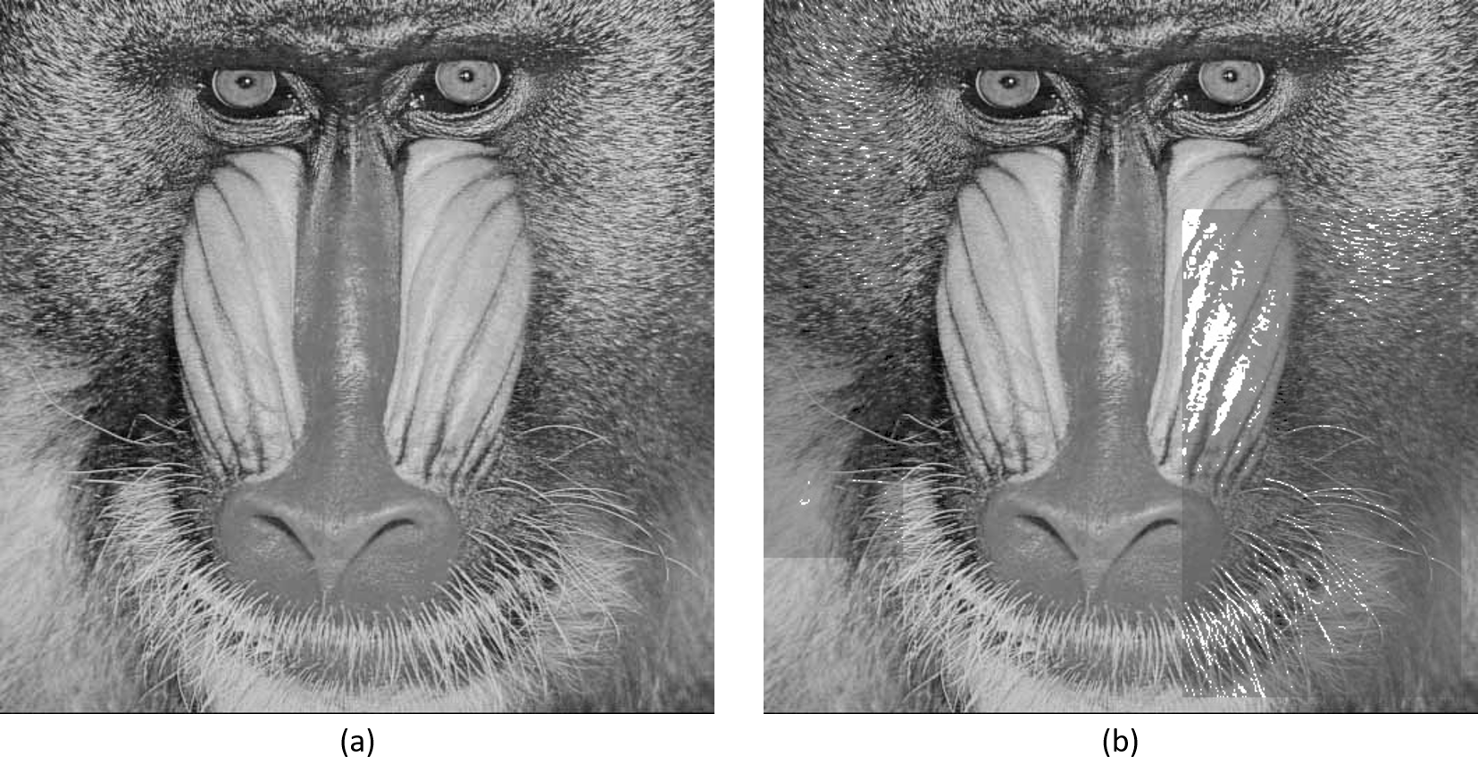

Figure 1 (a) Original Image (b) Modified Image

1. Original image
2. (a,b) = (20,200) for ROI1

(a,b) = (30, 190) for ROI2

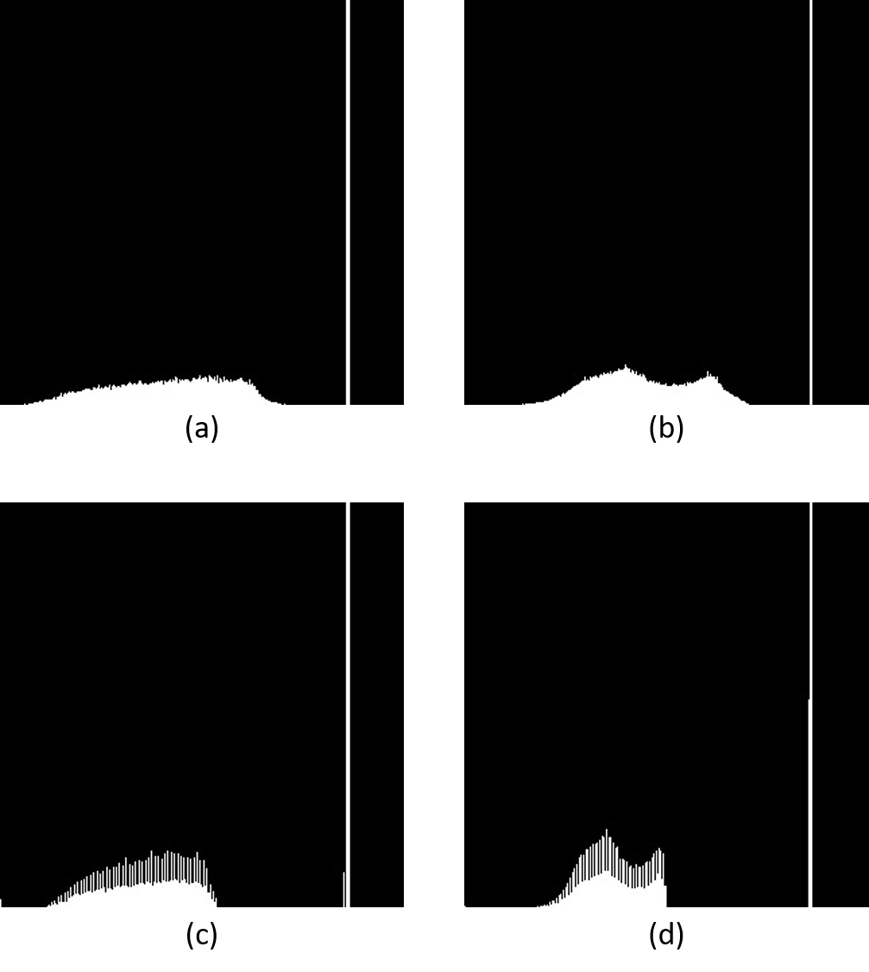

Figure 2 stretching on ROIs

1. Original ROI1
2. Original ROI2
3. (a,b) = (20,200) for ROI1
4. (a,b) = (30, 190) for ROI2

## Threshold Stretching

Threshold Stretching is combination of histogram modification with thresholding. It is defined by user provided intensity range parameters (a,b) and threshold. All pixels divided into two parts: dark and bright, then the algorithm of stretching apply to each set of pixels seperatly.

* Dark Part:
$$\begin{matrix}if I\left(i,j\right)<T & { I}^{'}{\left(i,j\right)}_{d}=\left\{\begin{matrix}0 & if 0 ≤I\left(i,j\right)≤a1 \\ \left(I\left(i,j\right)-c\right)×\frac{b1-a1}{d-c}+a1 & if a1<I\left(i,j\right)<b1 \\ 255 & if b1≤I\left(i,j\right)≤255\end{matrix}\right.\end{matrix}$$

* Bright Part:

$$\begin{matrix}if I\left(i,j\right)≥T & { I}^{'}{\left(i,j\right)}_{b}=\left\{\begin{matrix}0 & if 0 ≤I\left(i,j\right)≤a2 \\ \left(I\left(i,j\right)-c\right)×\frac{b2-a2}{d-c}+a2 & if a2<I\left(i,j\right)<b2 \\ 255 & if b2≤I\left(i,j\right)≤255\end{matrix}\right.\end{matrix}$$

The stretching applies the user defined ROI.

**Parameters**

|  |  |  |
| --- | --- | --- |
| src: | Address of source image | |
| tgt: | Modified image is saved in this address | |
| Input Vector: | roi_number | Number of defined ROI |
| ROI | Coordinate of target pixels |
| Dark range | Stretching dark part from a1 to b1 |
|  | Bright range | Stretching bright part from a2 to b2 |

### **Example**

SampleImages\Gray\floor.pgm OutputImages\floor_tstretching.pgm tstretching 3 0 0 500 100 100 10 70 100 150 100 200 300 300 140 30 70 150 220 420 150 500 360 200 0 50 200 255

|  |  |  |
| --- | --- | --- |
| Image Address | SampleImages\Gray\floor.pgm | Address of input image |
| OutputImages\floor_ tstretching.pgm | Address of modified image |
| Function | tstretching | Function name |
| ROI | 3 | Number of ROI |
| First Input | 0 | Coordinate of up-left X of 1st ROI |
| 0 | Coordinate of up-left Y of 1st ROI |
| 500 | Coordinate of down-right X of 1st ROI |
| 100 | Coordinate of down-right Y of 1st ROI |
|  | a1 is element of (a1, b1) |
|  | b1 is element of (a1, b1) |
|  | a2 is element of (a2, b2) |
| 100 | b2 is element of (a2, b2) |
| Second Input | 100 | Coordinate of up-left X of 2ed ROI |
| 200 | Coordinate of up-left Y of 2ed ROI |
| 300 | Coordinate of down-right X of 2ed ROI |
| 300 | Coordinate of down-right Y of 2ed ROI |
|  | a1 is element of (a1, b1) |
|  | b1 is element of (a1, b1) |
| 300 | a2 is element of (a2, b2) |
| 300 | b2 is element of (a2, b2) |
| Third Input | 420 | Coordinate of up-left X of 3rd ROI |
| 150 | Coordinate of up-left Y of 3rd ROI |
| 500 | Coordinate of down-right X of 3rd ROI |
| 360 | Coordinate of down-right Y of 3rd ROI |
|  | a1 is element of (a1, b1) |
|  | b1 is element of (a1, b1) |
| 500 | a2 is element of (a2, b2) |
| 360 | b2 is element of (a2, b2) |

### **Output**

Threshold Stretching with 3 ROIs (ROI1: top, ROI2: middle, ROI3: bottom-right)

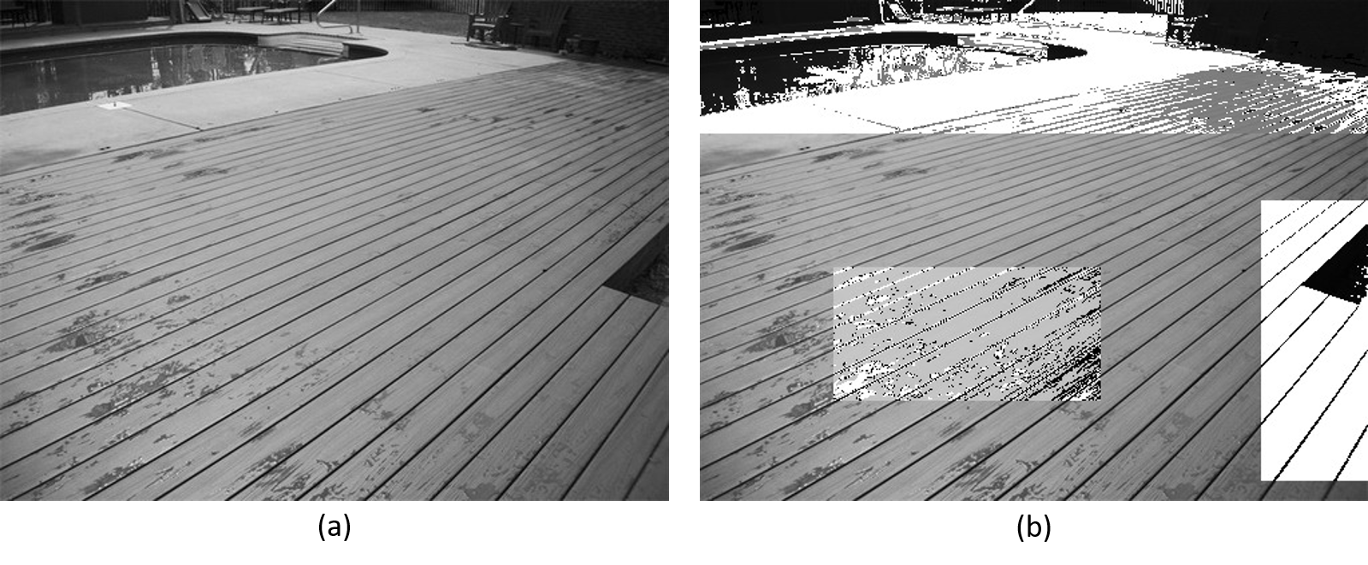

Figure 3 (a) Original Image (b) Modified Image

1. Original image
2. Threshold = 100 and (ad,bd) = (10, 70) and (ab,bb) = (100, 150), for ROI1

Threshold = 140 and (ad,bd) = (30, 70) and (ab,bb) = (150, 220), for ROI2

Threshold = 200 and (ad,bd) = (0, 50) and (ab,bb) = (200, 255), for ROI3

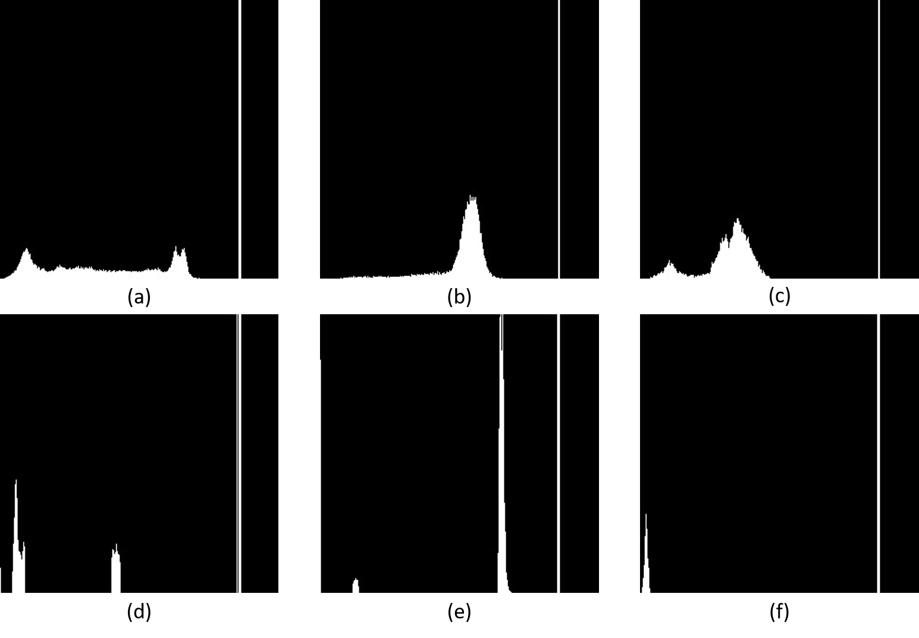

Figure 4 threshold stretching on ROIs

1. Original ROI1
2. Original ROI2
3. Original ROI3
4. (ad,bd) = (10, 70) and (ab,bb) = (100, 150)
5. (ad,bd) = (30, 70) and (ab,bb) = (150, 220)
6. (ad,bd) = (0, 50) and (ab,bb) = (200, 255)

## Channel Stretching

Channel Stretching is defined by user provided intensity range parameters (a,b) on one channel of color image. Stretch the specific channel’s intensities in the range between a and b on the input image to the range of c and d as output.

$$I^{'}\left(i,j\right)=\left\{\begin{matrix}0 & if 0 ≤I\left(i,j\right)≤a \\ \left(I\left(i,j\right)-c\right)×\frac{b-a}{d-c}+a & if a<I\left(i,j\right)<b \\ 255 & if b≤I\left(i,j\right)≤255\end{matrix}\right.$$

The stretching applies the user defined ROI.

**Parameters**

|  |  |  |
| --- | --- | --- |
| src: | Address of source image | |
| tgt: | Modified image is saved in this address | |
| Input Vector: | roi_number | Number of defined ROI |
| ROI | Coordinate of target pixels |
| channel | R, G, B |
| range | Stretching range from a to b |

### **Example**

SampleImages\Color\lena.ppm OutputImages\lena_chstretching.ppm chstretching 2 50 180 300 512 g 20 180 50 30 462 150 b 60 230

|  |  |  |
| --- | --- | --- |
| Image Address | SampleImages\Color\lena.ppm | Address of input image |
| OutputImages\lena_chstretching.ppm | Address of modified image |
| Function | chstretching | Function name |
| ROI | 2 | Number of ROI |
| First Input | 50 | Coordinate of up-left X of 1st ROI |
| 180 | Coordinate of up-left Y of 1st ROI |
| 300 | Coordinate of down-right X of 1st ROI |
| 512 | Coordinate of down-right Y of 1st ROI |
| 20 | a is element of (a, b) |
| 200 | b is element of (a, b) |
| Second Input | 50 | Coordinate of up-left X of 2ed ROI |
| 30 | Coordinate of up-left Y of 2ed ROI |
| 462 | Coordinate of down-right X of 2ed ROI |
| 150 | Coordinate of down-right Y of 2ed ROI |
| 30 | a is element of (a, b) |
| 190 | b is element of (a, b) |

### **Output**

Channel Stretching with 3 ROIs (ROI1: top, ROI2: left)

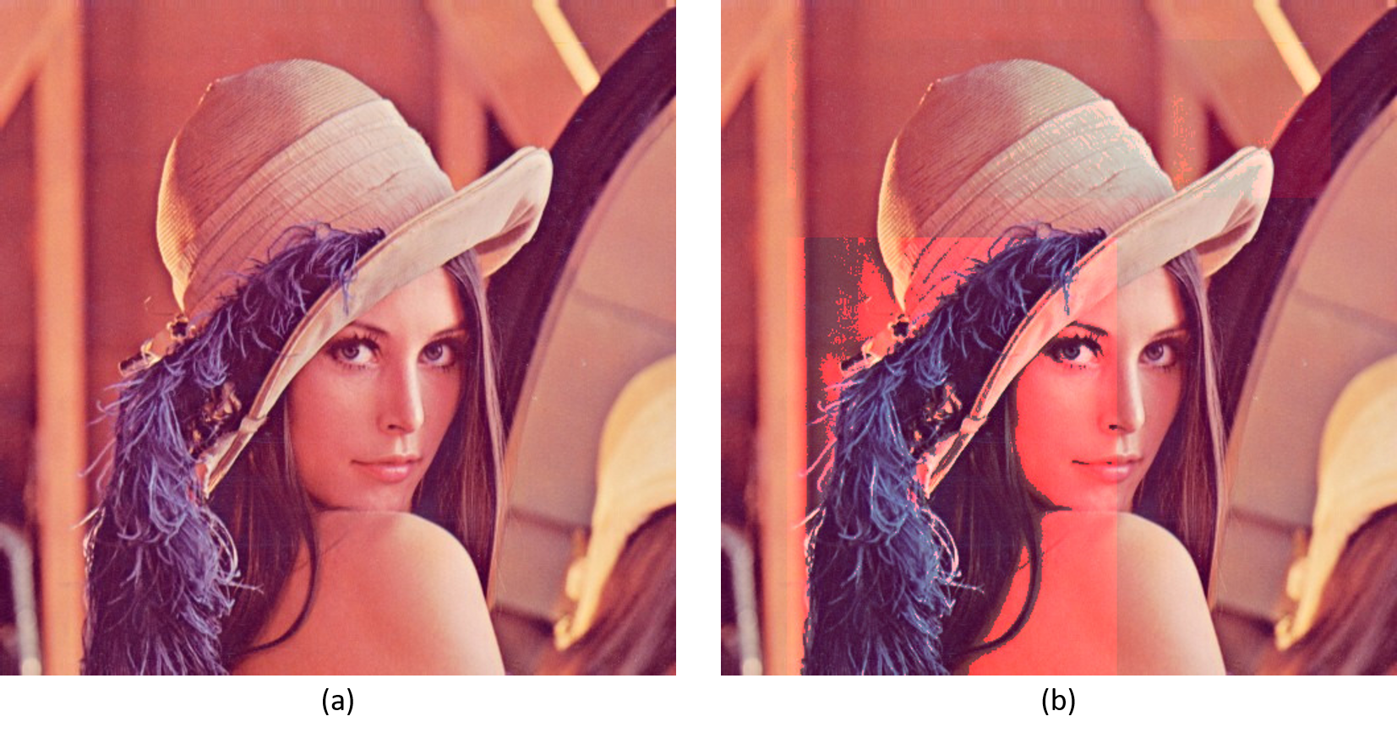

Figure 5 (a) Original Image (b) Modified Image

1. Original image
2. Channel = Green and (a,b) = (20,180) for ROI1

Channel = Blue and (a,b) = (60,230) for ROI2

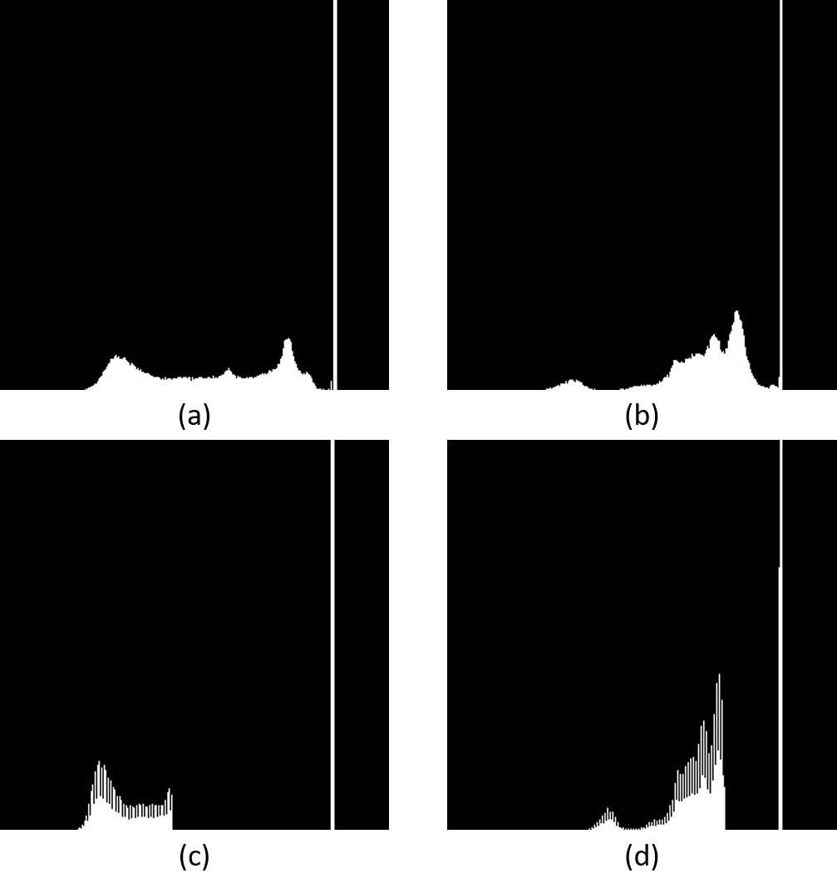

Figure 6 channel stretching on ROIs

1. Original ROI1
2. Original ROI2
3. (a,b) = (20,180)
4. (a,b) = (60,230))

## Color Stretching

Color Stretching is defined by user provided intensity range parameters (a,b) of color image. Stretch the intensities of all channel in the range between a and b on the input image to the range of c and d as output.

**Parameters**

|  |  |  |
| --- | --- | --- |
| src: | Address of source image | |
| tgt: | Modified image is saved in this address | |
| Input Vector: | roi_number | Number of defined ROI |
| ROI | Coordinate of target pixels |
| range | Stretching range from a to b |

### **Example**

SampleImages\Color\frog.ppm OutputImages\frog_cstretching.ppm cstretching 3 100 0 230 200 10 240 250 30 480 260 30 190

|  |  |  |
| --- | --- | --- |
| Image Address | SampleImages\Color\frog.ppm | Address of input image |
| OutputImages\frog_ cstretching.ppm | Address of modified image |
| Function | cstretching | Function name |
| ROI | 3 | Number of ROI |
| First Input | 100 | Coordinate of up-left X of 1st ROI |
| 0 | Coordinate of up-left Y of 1st ROI |
| 230 | Coordinate of down-right X of 1st ROI |
| 200 | Coordinate of down-right Y of 1st ROI |
| 10 | a is element of (a, b) |
| 240 | b is element of (a, b) |
| Second Input | 250 | Coordinate of up-left X of 2ed ROI |
| 30 | Coordinate of up-left Y of 2ed ROI |
| 480 | Coordinate of down-right X of 2ed ROI |
| 260 | Coordinate of down-right Y of 2ed ROI |
| 30 | a is element of (a, b) |
| 190 | b is element of (a, b) |

### **Output**

Color Stretching with 2 ROIs (ROI1: left, ROI2: right)

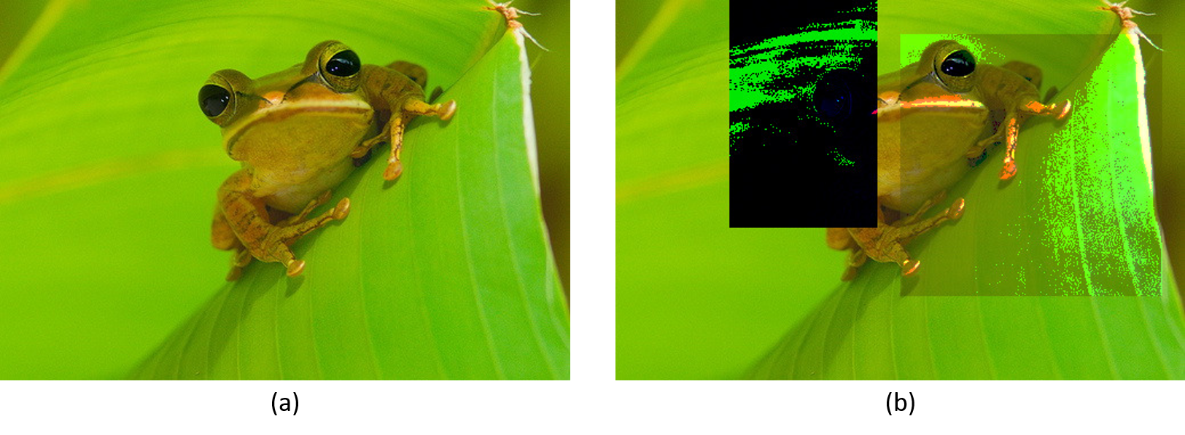

Figure 7 (a) Original Image (b) Modified Image

1. Original image
2. (a,b) = (200,240) for ROI1

(a,b) = (30,190) for ROI2

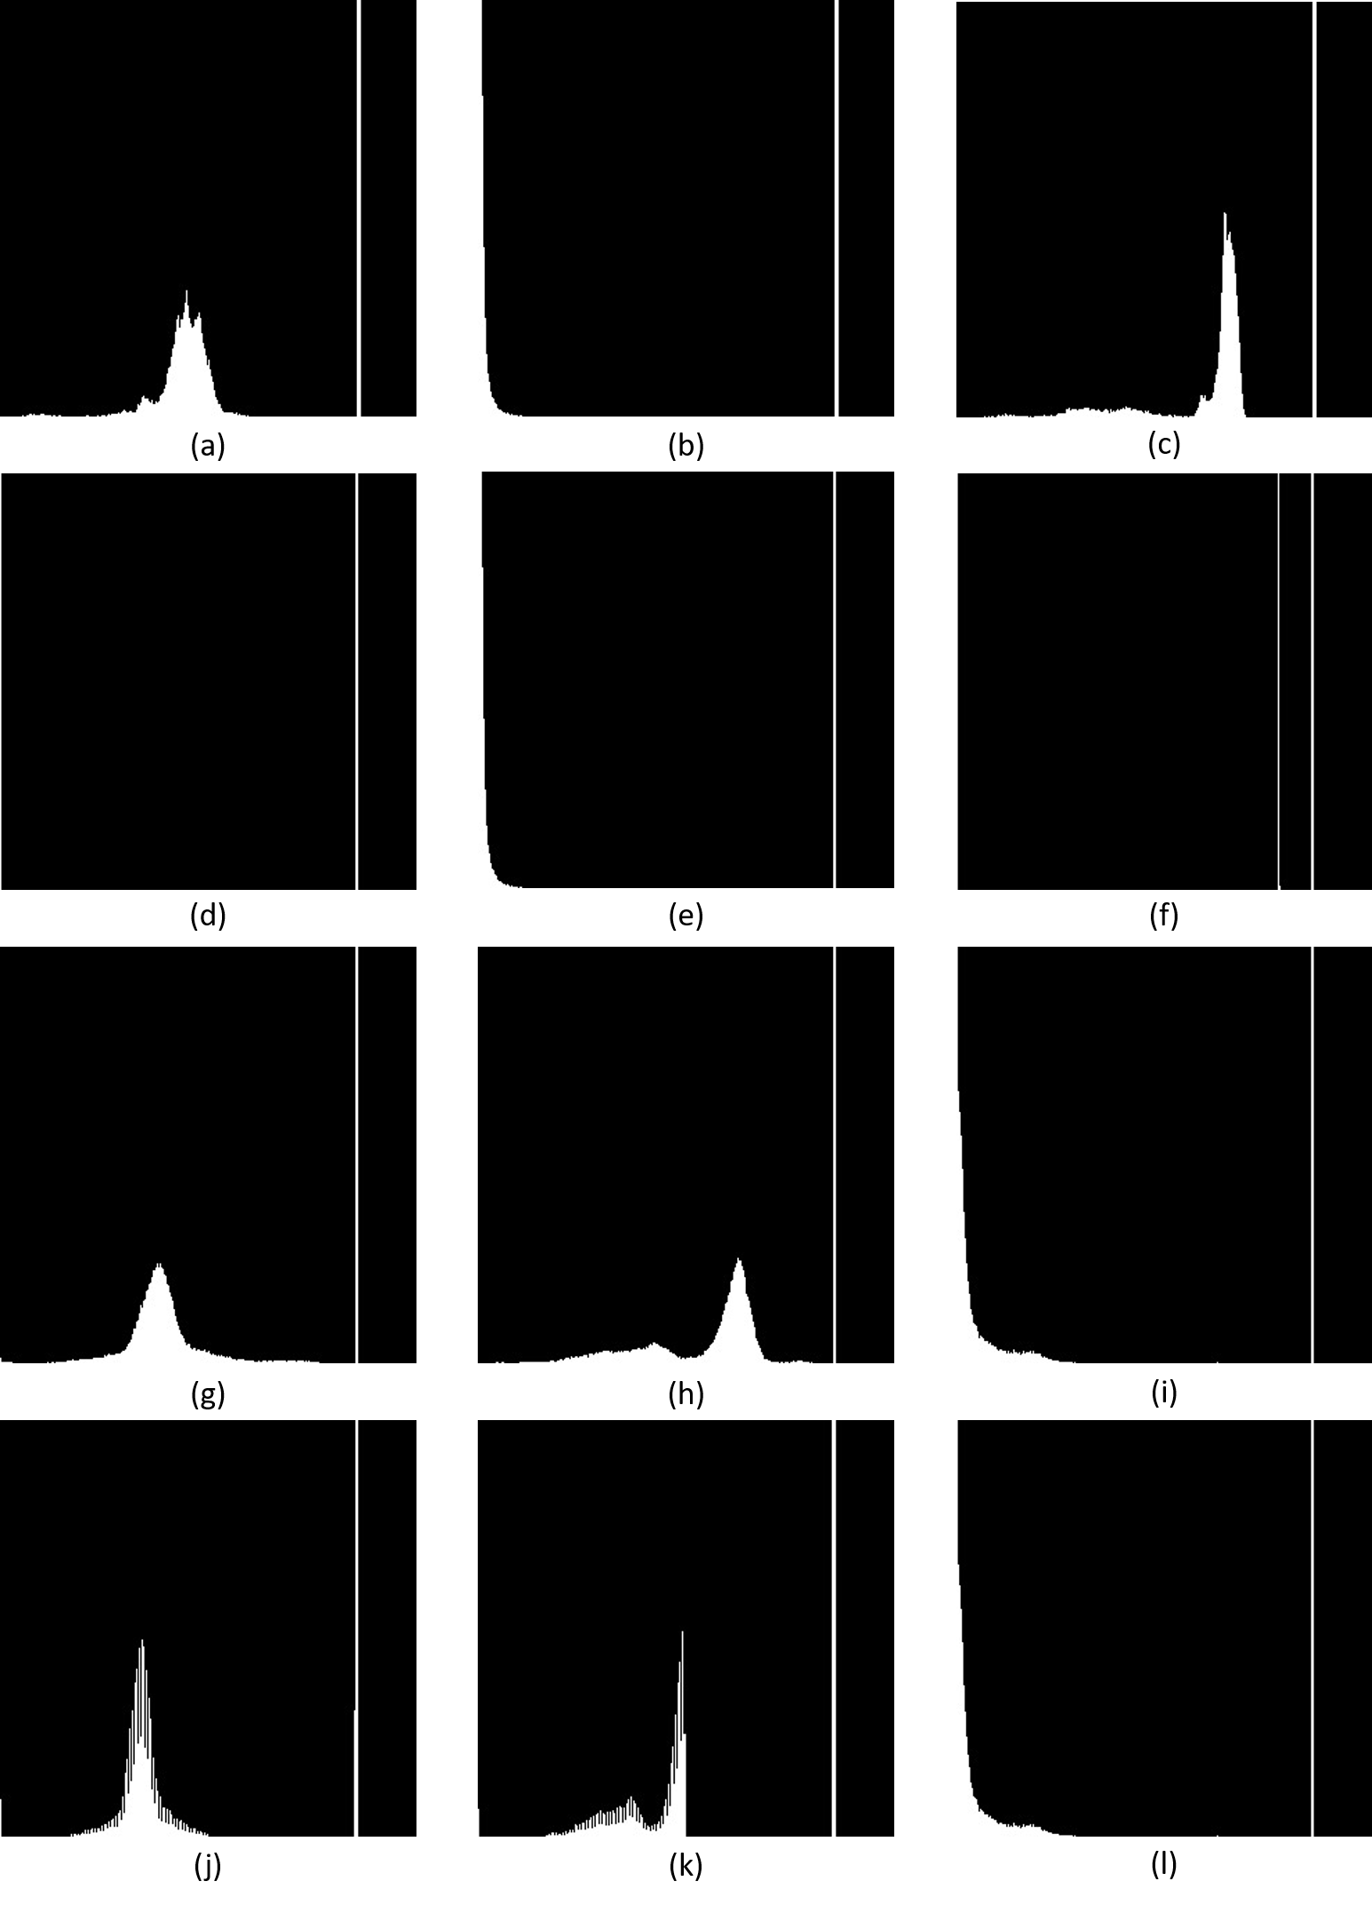

Figure 8 color stretching on ROIs

1. Original R channel ROI1
2. Original G channel ROI1
3. Original B channel ROI1
4. Channel R: (a,b) = (200,240) for ROI1
5. Channel G: (a,b) = (200,240) for ROI1
6. Channel B: (a,b) = (200,240) for ROI1
7. Original R channel ROI2
8. Original G channel ROI2
9. Original B channel ROI2
10. Channel R: (a,b) = (30,190) for ROI2
11. Channel G: (a,b) = (30,190) for ROI2
12. Channel B: (a,b) = (30,190) for ROI2

## Hue Stretching

This function is similar to Channel Stretching.

First of all, the input image convert from RGB to HSI. After that, stretch only the Hue channel histogram. At final, convert the result from HIS to RGB.

**Parameters**

|  |  |  |
| --- | --- | --- |
| src: | Address of source image | |
| tgt: | Modified image is saved in this address | |
| Input Vector: | roi_number | Number of defined ROI |
| ROI | Coordinate of target pixels |
| range | Stretching range from a to b |

Example

SampleImages\Color\flower.ppm OutputImages\flower_hstretching.ppm hstretching 3 0 0 100 100 200 270 230 80 430 280 50 200 0 270 100 374 0 100

|  |  |  |
| --- | --- | --- |
| Image Address | SampleImages\Color\flower.ppm | Address of input image |
| OutputImages\flower_hstretching.ppm | Address of modified image |
| Function | hstretching | Function name |
| ROI | 3 | Number of ROI |
| First Input | 0 | Coordinate of up-left X of 1st ROI |
| 0 | Coordinate of up-left Y of 1st ROI |
| 100 | Coordinate of down-right X of 1st ROI |
| 100 | Coordinate of down-right Y of 1st ROI |
| 0 | a is element of (a, b) |
| 100 | b is element of (a, b) |
| Second Input | 230 | Coordinate of up-left X of 2ed ROI |
| 80 | Coordinate of up-left Y of 2ed ROI |
| 430 | Coordinate of down-right X of 2ed ROI |
| 280 | Coordinate of down-right Y of 2ed ROI |
| 230 | a is element of (a, b) |
| 280 | b is element of (a, b) |
| Third Input | 0 | Coordinate of up-left X of 3rd ROI |
| 270 | Coordinate of up-left Y of 3rd ROI |
| 100 | Coordinate of down-right X of 3rd ROI |
| 374 | Coordinate of down-right Y of 3rd ROI |
| 100 | a is element of (a, b) |
| 374 | b is element of (a, b) |

### **Output**

Hue Stretching with 3 ROIs (ROI1: top-left, ROI2: middle, ROI3: bottom-left)

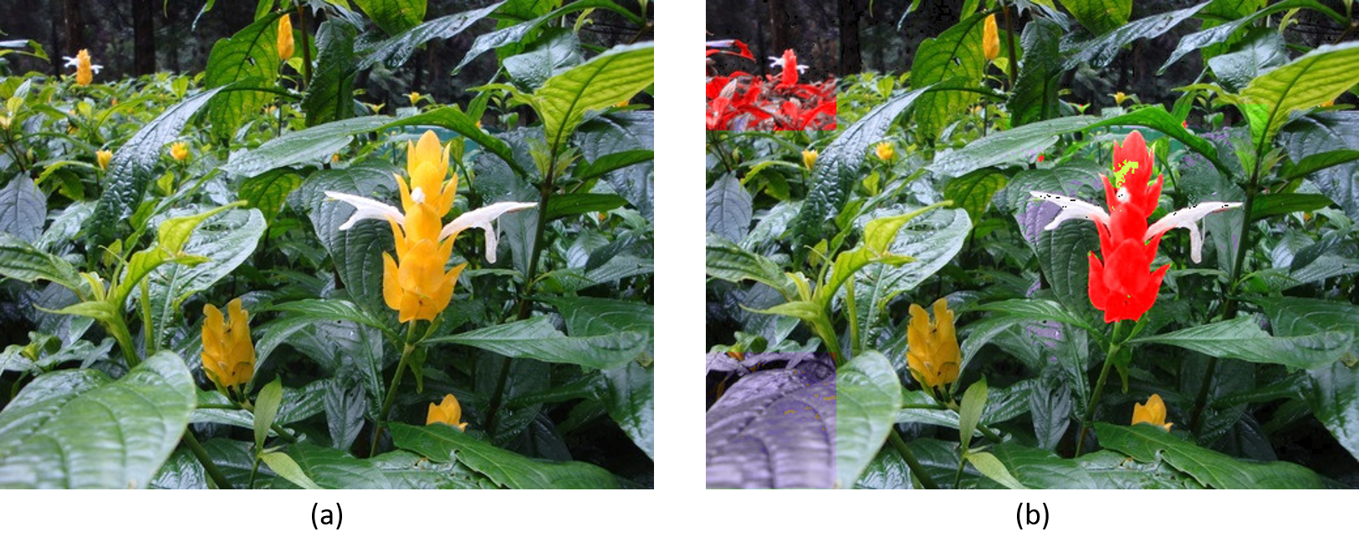

Figure 9 (a) Original Image (b) Modified Image

1. Original image
2. (a,b) = (200,270) for ROI1

(a,b) = (50,200) for ROI2

(a,b) = (0,100) for ROI3

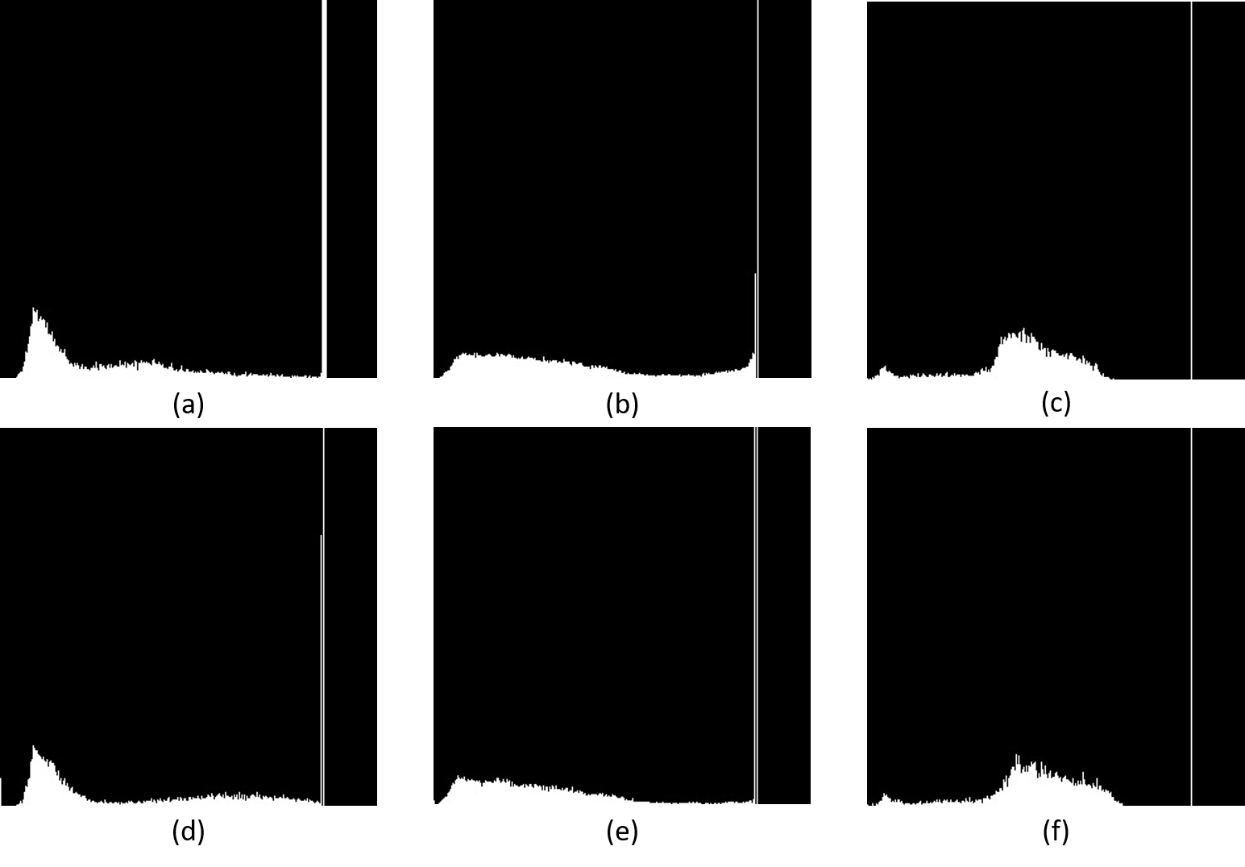

Figure 10 hue stretching on ROIs

1. Original ROI1
2. Original ROI2
3. Original ROI3
4. Hue Stretching (a,b) = (200,270)
5. Hue Stretching (a,b) = (50,200)
6. Hue Stretching (a,b) = (0,100) for ROI3

## Hue and Intensity Stretching

This function is similar to Hue Stretching. But in this function stretch the saturation too.

First of all, the input image convert from RGB to HSI. After that, stretch the Hue and Saturation channel histogram. At final, convert the result from HIS to RGB.

**Parameters**

|  |  |  |
| --- | --- | --- |
| src: | Address of source image | |
| tgt: | Modified image is saved in this address | |
| Input Vector: | roi_number | Number of defined ROI |
| ROI | Coordinate of target pixels |
| Hue range | Stretching range from a1 to b1 |
| Saturation range | Stretching range from a2 to b2 |

Example

SampleImages\Color\flower.ppm OutputImages\flower_hsstretching.ppm hsstretching 3 0 0 100 100 200 270 10 80 230 80 430 280 50 200 10 60 0 270 100 374 0 100 0 50

|  |  |  |
| --- | --- | --- |
| Image Address | SampleImages\Color\flower.ppm | Address of input image |
| OutputImages\flower_hsstretching.ppm | Address of modified image |
| Function | hsstretching | Function name |
| ROI | 3 | Number of ROI |
| First Input | 0 | Coordinate of up-left X of 1st ROI |
| 0 | Coordinate of up-left Y of 1st ROI |
| 100 | Coordinate of down-right X of 1st ROI |
| 100 | Coordinate of down-right Y of 1st ROI |
| 0 | a1 is element of (a1, b1) |
| 100 | b1 is element of (a1, b1) |
| 20 | a2 is element of (a2, b2) |
| 80 | b2 is element of (a2, b2) |
| Second Input | 230 | Coordinate of up-left X of 2ed ROI |
| 80 | Coordinate of up-left Y of 2ed ROI |
| 430 | Coordinate of down-right X of 2ed ROI |
| 280 | Coordinate of down-right Y of 2ed ROI |
| 230 | a1 is element of (a1, b1) |
| 280 | b1 is element of (a1, b1) |
| 230 | a2 is element of (a2, b2) |
| 280 | b2 is element of (a2, b2) |
| Third Input | 0 | Coordinate of up-left X of 3rd ROI |
| 270 | Coordinate of up-left Y of 3rd ROI |
| 100 | Coordinate of down-right X of 3rd ROI |
| 374 | Coordinate of down-right Y of 3rd ROI |
|  | a1 is element of (a1, b1) |
|  | b1 is element of (a1, b1) |
| 100 | a2 is element of (a2, b2) |
| 374 | b2 is element of (a2, b2) |

### **Output**

Hue and Staturation Stretching with 3 ROIs (ROI1: top-left, ROI2: middle, ROI3: bottom-left)

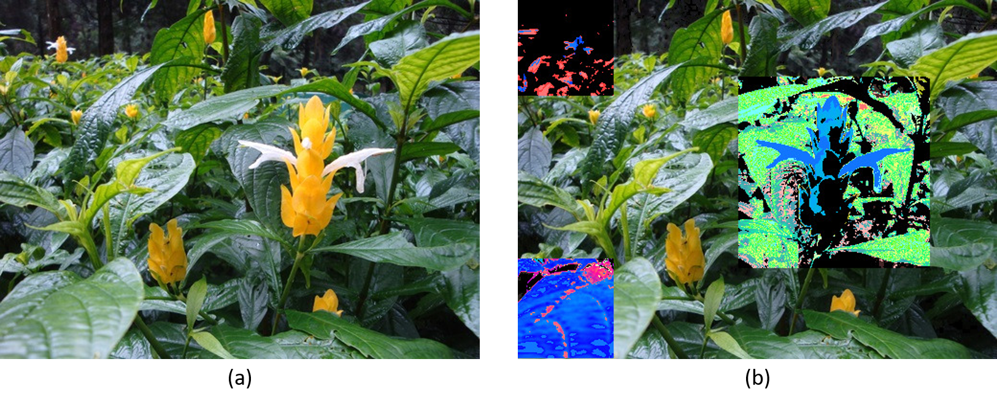

Figure 11 (a) Original Image (b) Modified Image

1. Original image
2. Hue (a,b) = (200,270) and Saturation (a,b) = (10,80) for ROI1

Hue (a,b) = (50,200) and Saturation (a,b) = (10,60) for ROI2

Hue (a,b) = (0,100) and Saturation (a,b) = (0,50) for ROI3

## Hue, Saturation and Intensity Stretching

This function is similar to Hue Stretching. But in this function stretch the saturation and intensity too.

First of all, the input image convert from RGB to HSI. After that, stretch the Hue, Saturation and Intensity channel histogram. At final, convert the result from HIS to RGB.

**Parameters**

|  |  |  |
| --- | --- | --- |
| src: | Address of source image | |
| tgt: | Modified image is saved in this address | |
| Input Vector: | roi_number | Number of defined ROI |
| ROI | Coordinate of target pixels |
| Hue range | Stretching range from a1 to b1 |
| Saturation range | Stretching range from a2 to b2 |
| Intensity range | Stretching range from a3 to b3 |

Example

SampleImages\Color\flower.ppm OutputImages\flower_hsistretching.ppm hsistretching 3 0 0 100 100 200 270 10 80 100 150 230 80 430 280 50 200 10 60 40 90 0 270 100 374 0 100 0 50 20 200

|  |  |  |
| --- | --- | --- |
| Image Address | SampleImages\Color\flower.ppm | Address of input image |
| OutputImages\flower_hsstretching.ppm | Address of modified image |
| Function | hsstretching | Function name |
| ROI | 3 | Number of ROI |
| First Input | 0 | Coordinate of up-left X of 1st ROI |
| 0 | Coordinate of up-left Y of 1st ROI |
| 100 | Coordinate of down-right X of 1st ROI |
| 100 | Coordinate of down-right Y of 1st ROI |
| 0 | a1 is element of (a1, b1) |
| 100 | b1 is element of (a1, b1) |
|  | a2 is element of (a2, b2) |
|  | b2 is element of (a2, b2) |
| 20 | a3 is element of (a3, b3) |
| 80 | b3 is element of (a3, b3) |
| Second Input | 230 | Coordinate of up-left X of 2ed ROI |
| 80 | Coordinate of up-left Y of 2ed ROI |
| 430 | Coordinate of down-right X of 2ed ROI |
| 280 | Coordinate of down-right Y of 2ed ROI |
| 230 | a1 is element of (a1, b1) |
| 280 | b1 is element of (a1, b1) |
|  | a2 is element of (a2, b2) |
|  | b2 is element of (a2, b2) |
| 230 | a3 is element of (a3, b3) |
| 280 | b3 is element of (a3, b3) |
| Third Input | 0 | Coordinate of up-left X of 3rd ROI |
| 270 | Coordinate of up-left Y of 3rd ROI |
| 100 | Coordinate of down-right X of 3rd ROI |
| 374 | Coordinate of down-right Y of 3rd ROI |
|  | a1 is element of (a1, b1) |
|  | b1 is element of (a1, b1) |
|  | a2 is element of (a2, b2) |
|  | b2 is element of (a2, b2) |
| 100 | a3 is element of (a3, b3) |
| 374 | b3 is element of (a3, b3) |

### **Output**

Hue, Saturation and Intensity Stretching with 3 ROIs (ROI1: top-left, ROI2: middle, ROI3: bottom-left)

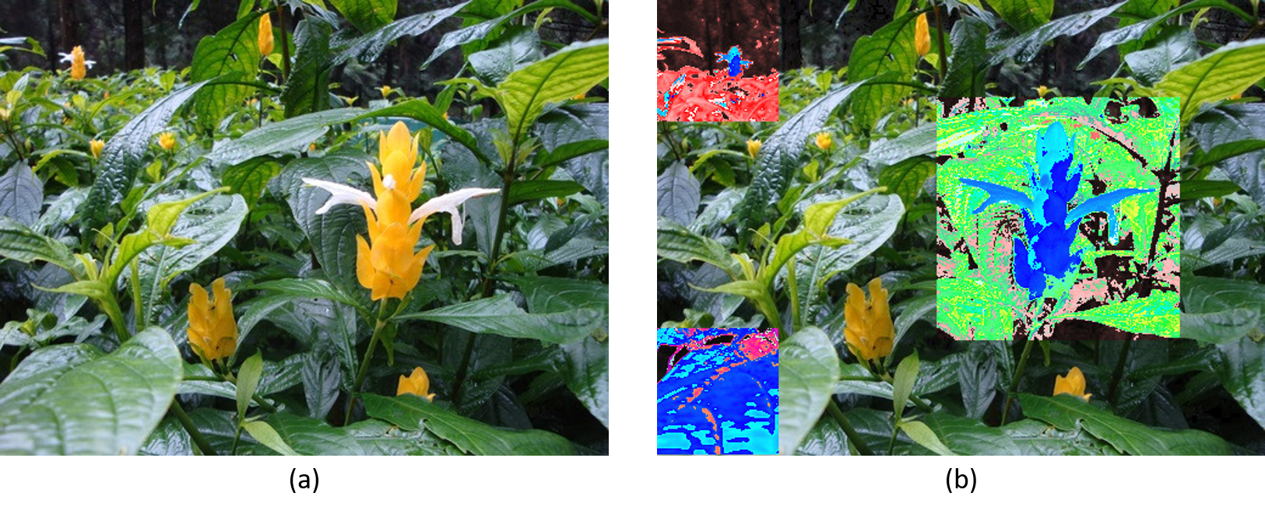

Figure 12 (a) Original Image (b) Modified Image

1. Original image
2. Hue (a,b) = (200,270) and Saturation (a,b) = (10,80) and Intensity (a,b) = (100,150) for ROI1

Hue (a,b) = (50,200) and Saturation (a,b) = (10,60) and Intensity (a,b) = (40, 90) for ROI2

Hue (a,b) = (0,100) and Saturation (a,b) = (0,50) and Intensity (a,b) = (20,200) for ROI3

# HSI Stretching

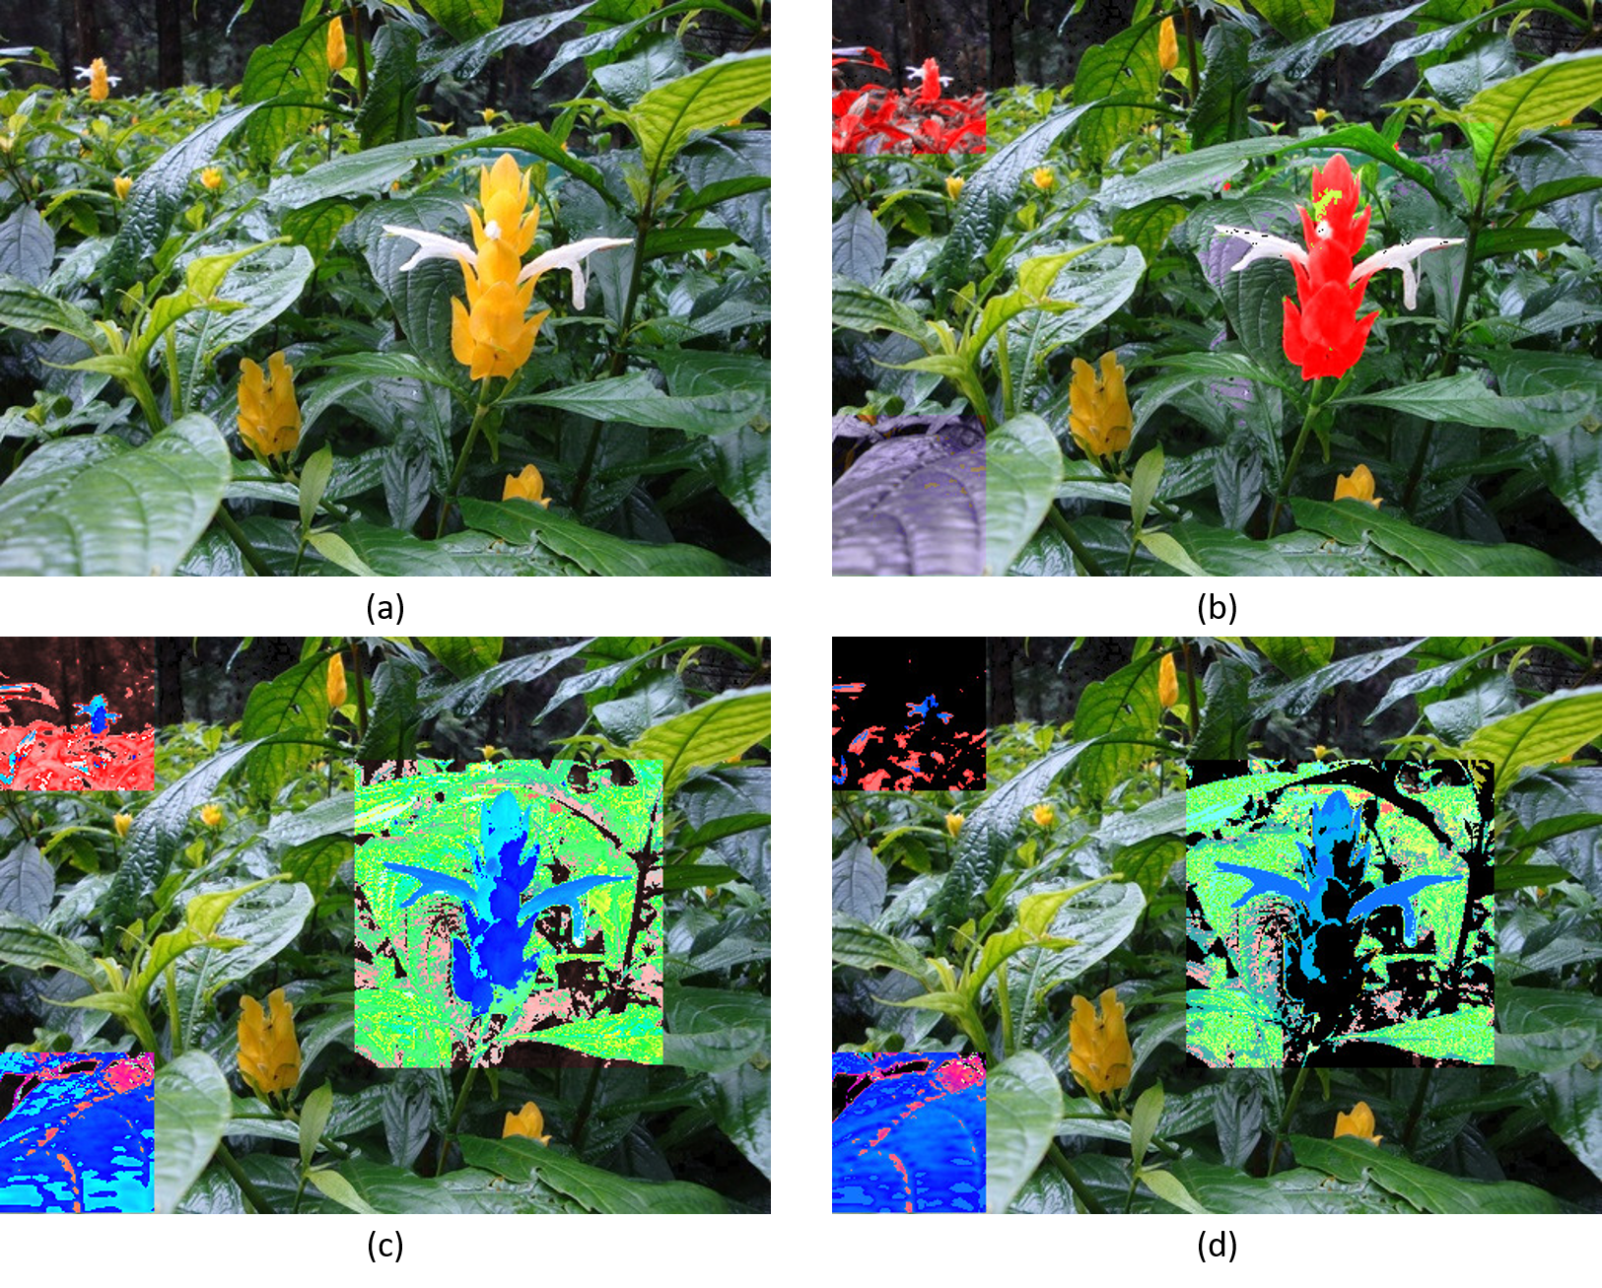

Figure 13 (a) Original image (b) Hue Stretching (c) Hue and Saturation Stretching (d) Hue, Saturation and Intensity stretching

Based on Figure 13, saturation stretching affects the range of each color. For example, the bottom-left ROI in image (b) is light purple. But with saturation stretching you can see in image (c), it is getting multi-color (blue, dark blue, pink and …). Also, it effects on saturate of colors. The up-left ROI in image (b) and (c) have different saturation.

As you can see in image (d), intensity stretching effects on brightness of ROIs. In image (d) in the middle ROI, we can see darker color and most of color is getting black (it could make the color brighter based on the range of stretching).